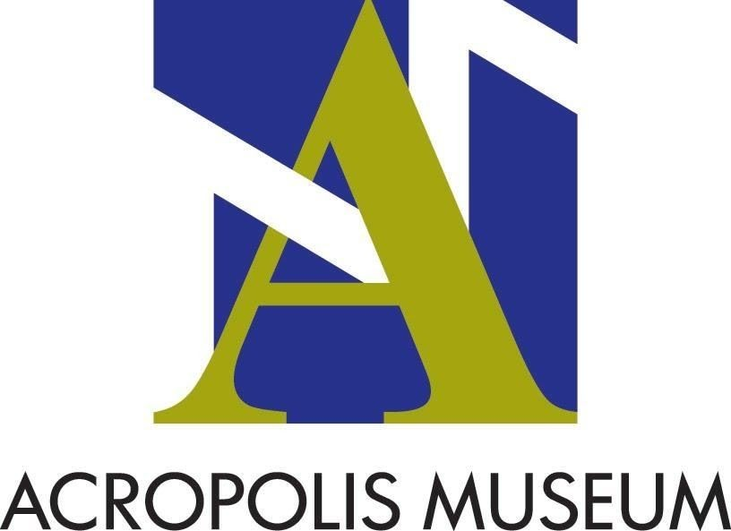

APPLICATION FOR PERMISSION TO FILM AND USE FOOTAGE
(please fill-in or underline as appropriate)

Applicant’s Contact Information
Name/Organisation:
Address:
Telephone and fax number:
E-mail adress:
Profession:

The material to be filmed will be used in the production of:

- cultural documentary – informative content
- film/program for educational purposes
- film in which the Museum is a setting but not the subject
- film for advertising purposes (please identify the product being advertised):
- other (please specify):

Production details
Director:
Producer:
Title:

Distribution / commercial use
Company name: Contact person:
Τel. & fax & e-mail address:

Title of production:

Type of production:
No of copies:
Production (countries):
Language:
Distribution (countries):

Identify length of final product:
up to 15’ up to 30’ up to 45’ up to 60’ more than 60’

Company Information / Invoicing Details
Company name:
Profession:
Address:
City:
Postcode:
VAT number:

Phone number:

Filming will include:
People:
Text, subtitles, narration, etc:

(Please attach the script to your application)

In case of use of the film in the internet: Duration of use of the material:
Website URL: Website genre: Languages:

Preferred date/hours and duration of visit:

Where will the filming take place?
1. Courtyard Area 2. Ground floor / Gallery of the Slopes
3. Level 1 - Archaic Gallery 4. Level 1 - 5th B.C. - 5th A.D.
5. Level 3 - Parthenon Gallery 6. Archaeological Excavation

Exhibits included in the filming (please specify how the exhibits will be filmed) Catalogue No. Title View
1.
2.
3.
4.
5.
6.
7.
8.
9.
10.

(please use an additional A4 sheet if required)

Non authorized commercial use, distribution or public display of the filming material is prohibited by Greek copyright laws.

I declare hereby that I have read and agree to the “Terms and Conditions”.

(date)

(Signature)

